# OOP – Environment System

The goal of this lab is to study the **Environment System** and extend its functionality. You are **NOT allowed to directly edit** any of the contents of the **Core** and **Interface** namespaces (only the **Generator** namespace).

## Unstable Stars

Some stars don't have much luck and explode before they fall – and that's why they're most beautiful.

### Step 1 – Instability

Such stars have a **lifetime** – i.e. time before they explode. Create an unstable star that has a lifetime of **8** (8 frames of life). Just like the falling star, it should **fall in its direction** and **explode** after its **lifetime expires**. When it explodes, the falling star should produce an explosion with **radius** **2** in every direction, except the center. The explosion should persist for **2 frames** (have a lifetime of 2).

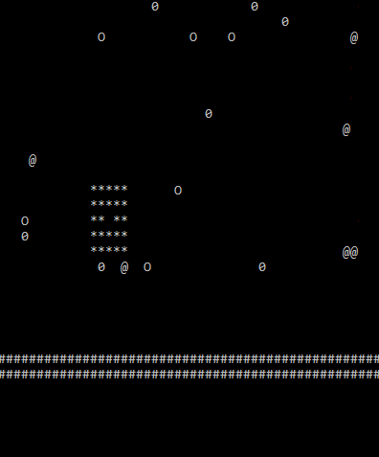

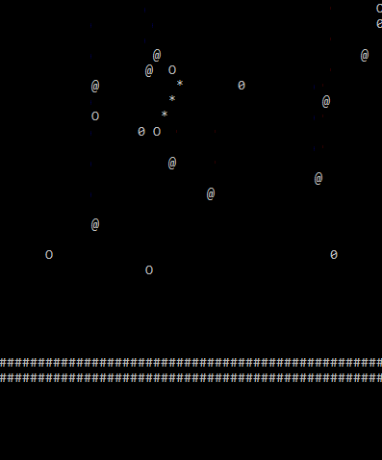

### Step 2 – Explosion Damage

Whenever any **explosion** from an unstable star occurs, **all stars** (static stars, falling, other unstable stars) caught in the explosion radius should be **destroyed**.

Test this by adding several stars of different types and many unstable stars.